User can drag the location in the collection at the left panel into the schedule on the right panel. He or she can also adjust the timing of events by drag the event up and down.



After user select all the events, the application generates a plan for user when he or she clicks ‘Plan 1’, User can edit it or share to Telegram, WhatsApp or Facebook.

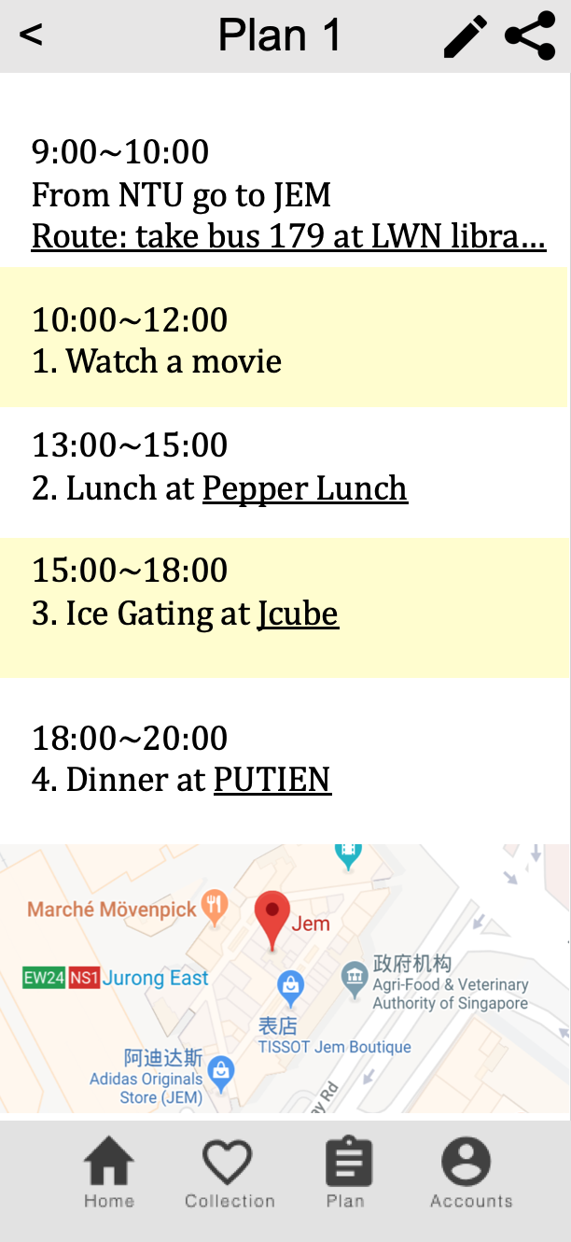

This is the page after user clicking on ‘Plan’ icon at the bottom. It shows future plans and past plans.

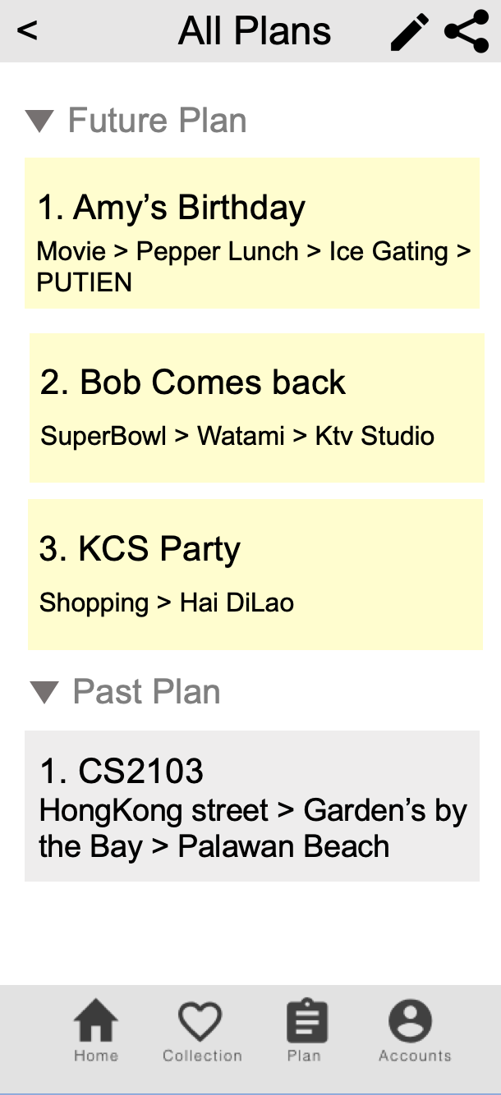

This is the page after clicking on ‘Account’ icon at the bottom. User can edit profile and settings here.

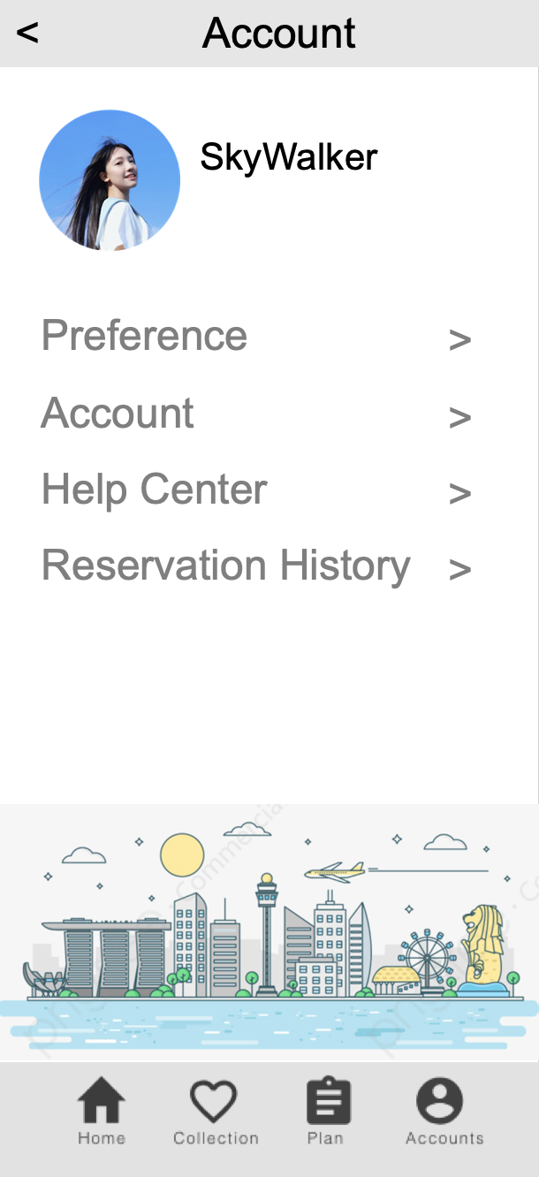

**Vendor Part**

After user login in as a vendor, he or she can find all the reservations at the home page. The system default is to accept all reservations. Vendor can slide a reservation to the right to reject it.

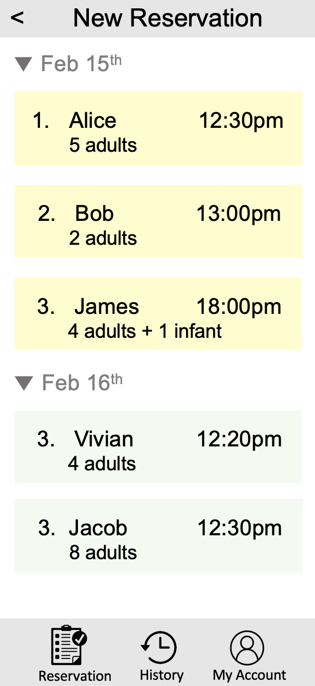

This is the page after user clicking on ‘History’ icon at the bottom. It shows all the past reservations including successful and unsuccessful ones.

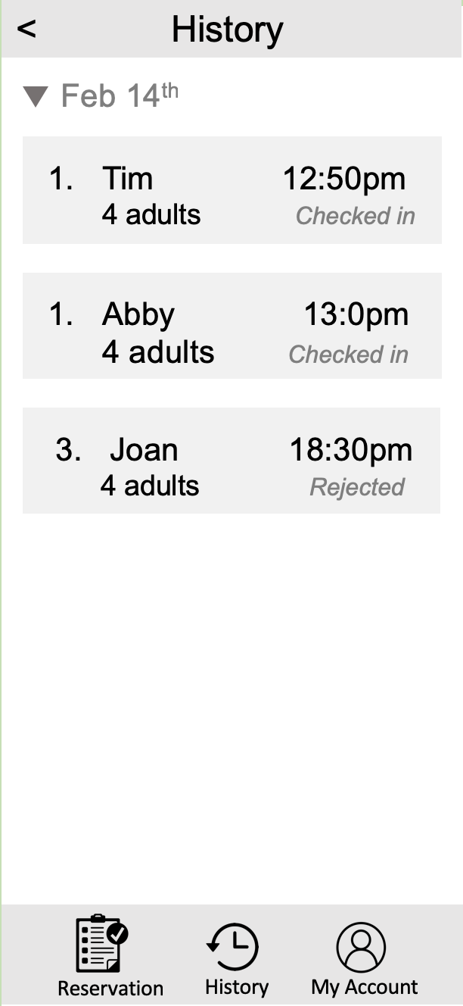

This is the page after user clicking on ‘My Account’ icon at the bottom. User can edit details of his shop (including address, phone number, operating hour, menu).

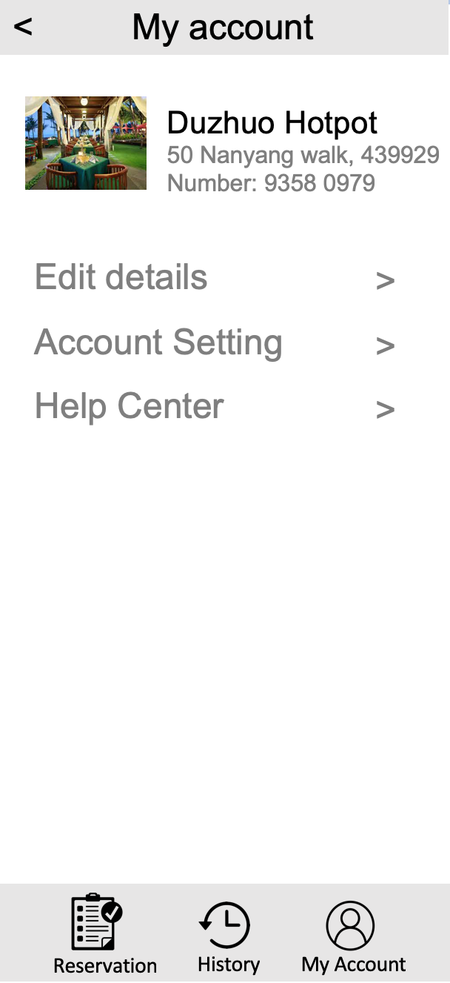

**Administrator Part**

This is the page displayed after user login in as administrator. It shows all submitted application of vendors. Each application contains an image of shop license and a statement. Administrator can click into an application to see details. He or she can verify or reject the application.

